**Practical 5**

**Aim:**

You are given a string and your task is to swap cases. In other words, convert all lowercase letters to uppercase letters and vice versa. Sample Input: HackerRank.com presents "Pythonist 2".

Sample Output: hACKERrANK.COM PRESENTS "pYTHONIST 2".

**S/W**:

PyCharm Community Edition 2021.3

**Theory:**

**swapcase()** - The swapcase() method returns a string where all the upper case letters are lower case and vice versa.

Syntax: string.swapcase()

**isupper() -** The isupper() method returns True if all the characters are in upper case, otherwise False. Numbers, symbols and spaces are not checked, only alphabet characters.

Syntax: string.isupper()

**islower() -** The islower() method returns True if all the characters are in lower case, otherwise False. Numbers, symbols and spaces are not checked, only alphabet characters.

Syntax: string.islower()

**lower() -** The lower() method returns the lowercased string from the given string. It converts all uppercase characters to lowercase. If no uppercase character exist, it returns the original string.

Syntax: string.lower()

**upper() -** The upper() method returns the uppercased string from the given string. It converts all lowercase characters to uppercase. If no lowercase character exist, it returns the original string.

Syntax: string.upper()

**Program:**

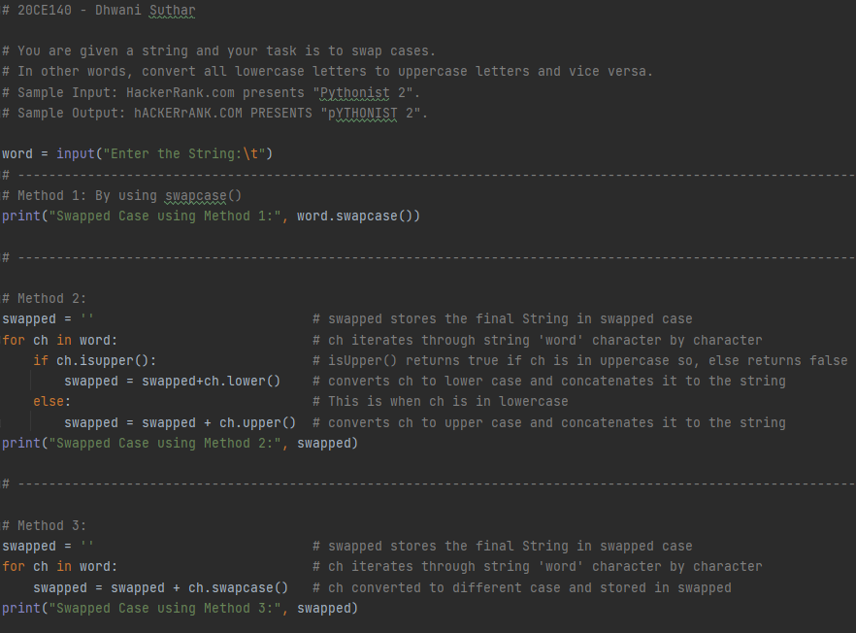

Method 1:

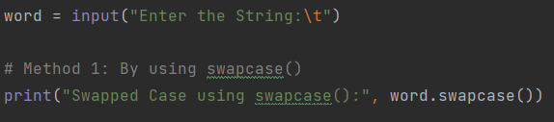

Method 2:

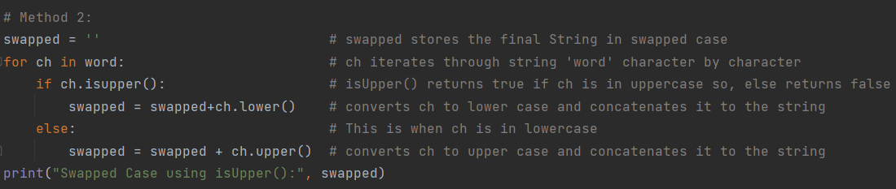

Method 3:

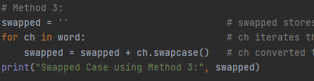

Code:

# 20CE140 - Dhwani Suthar  
  
# You are given a string and your task is to swap cases.  
# In other words, convert all lowercase letters to uppercase letters and vice versa.  
# Sample Input: HackerRank.com presents "Pythonist 2".  
# Sample Output: hACKERrANK.COM PRESENTS "pYTHONIST 2".  
  
word = input("Enter the String:\t")  
# -------------------------------------------------------------------------

# Method 1: By using swapcase()  
print("Swapped Case using Method 1:", word.swapcase())  
  
# -------------------------------------------------------------------------

# Method 2:  
swapped = '' # swapped stores the final String in swapped case  
for ch in word: # ch iterates through string 'word' character by character  
 if ch.isupper(): # isUpper() returns true if ch is in uppercase so, else returns false  
 swapped = swapped+ch.lower() # converts ch to lower case and concatenates it to the string  
 else: # This is when ch is in lowercase  
 swapped = swapped + ch.upper() # converts ch to upper case and concatenates it to the string  
print("Swapped Case using Method 2:", swapped)  
  
# -------------------------------------------------------------------------  
  
# Method 3:  
swapped = '' # swapped stores the final String in swapped case  
for ch in word: # ch iterates through string 'word' character by character  
 swapped = swapped + ch.swapcase() # ch converted to different case and stored in swapped  
print("Swapped Case using Method 3:", swapped)

**Output:**

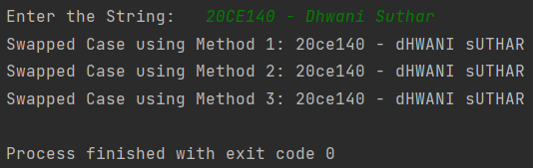

**Conclusion:**

swapcase() method can be used to convert from one case to another and even without checking its current and final case.

toupper() and tolower() is used to convert specifically to upper and lowercase respectively.